### **The Perfect Desktop Christmas Tree**

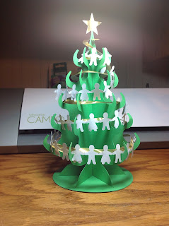

This Christmas tree has all the elements of a big tree but in a desktop version. I love the paper doll garland and the gold spiral garland. The ornaments can be resized for your room size tree.  
  
The Christmas tree is assembled by sliding the pieces together. Two of the pieces are exactly the same. Spread them apart and place them in the base so that the are all equally spaced. This is similar to the witch's hat base in another post. <http://papercraftetc.blogspot.com/2013/10/halloween-witchs-or-wizards-hats.html>

I used cardstock on the tree and ornaments. The spiral gold garland and the star on top of the tree is good quality wrapping paper. The paper doll garland is white copy paper.

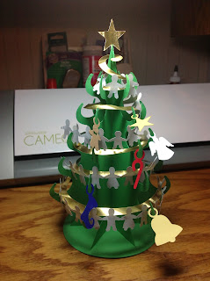

Merry Christmas!